**Єлін Євген РІ-41 мн**

# Лабораторна робота №1 Enigma Machine

Посилання на гітхаб:

<https://github.com/YelinYevgen/lab-1.git>

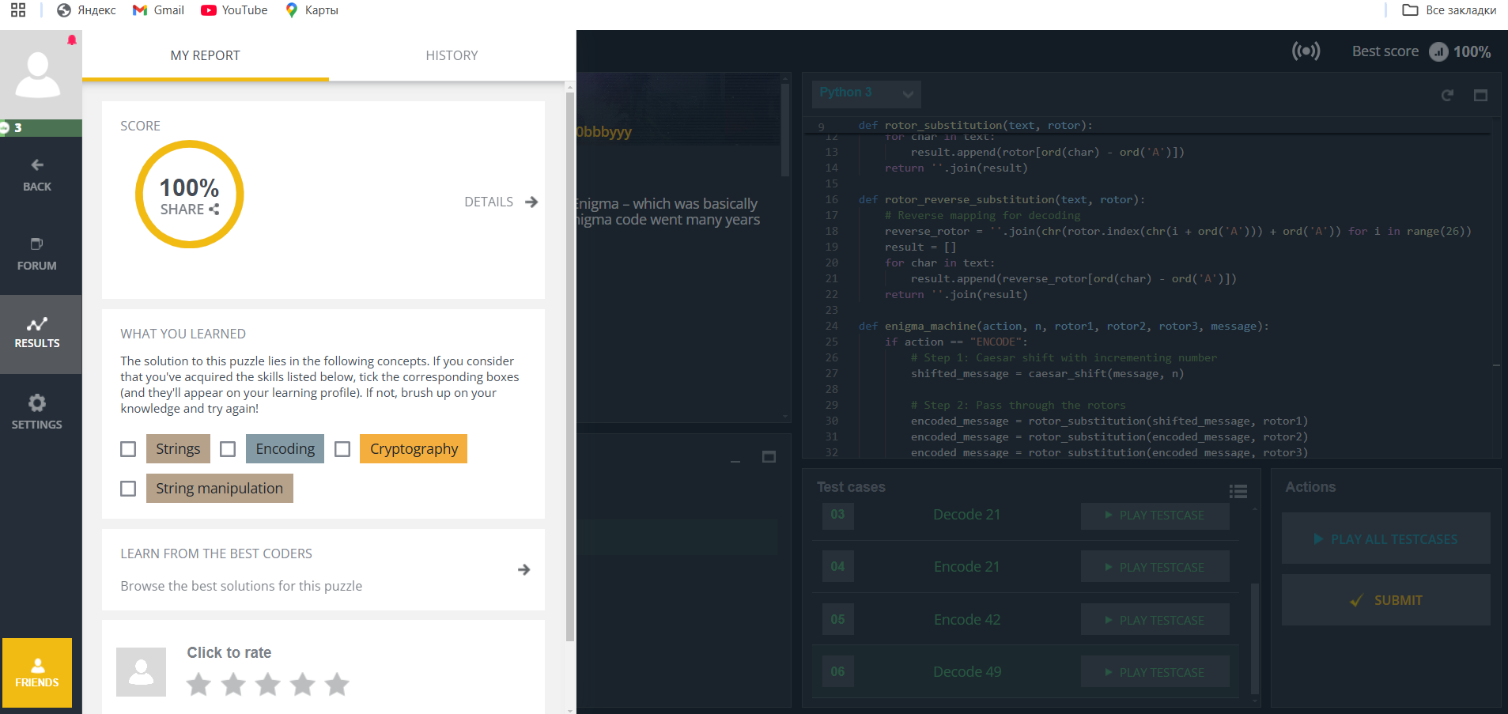

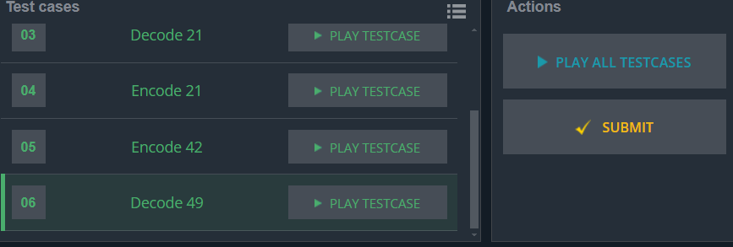

**Код програми на Python:**

def caesar_shift(text, shift):

# Incremental Caesar shift

result = []

for i, char in enumerate(text):

new_char = chr((ord(char) - ord('A') + shift + i) % 26 + ord('A'))

result.append(new_char)

return ''.join(result)

def rotor_substitution(text, rotor):

# Substitutes each character in text with its rotor mapping

result = []

for char in text:

result.append(rotor[ord(char) - ord('A')])

return ''.join(result)

def rotor_reverse_substitution(text, rotor):

# Reverse mapping for decoding

reverse_rotor = ''.join(chr(rotor.index(chr(i + ord('A'))) + ord('A')) for i in range(26))

result = []

for char in text:

result.append(reverse_rotor[ord(char) - ord('A')])

return ''.join(result)

def enigma_machine(action, n, rotor1, rotor2, rotor3, message):

if action == "ENCODE":

# Step 1: Caesar shift with incrementing number

shifted_message = caesar_shift(message, n)

# Step 2: Pass through the rotors

encoded_message = rotor_substitution(shifted_message, rotor1)

encoded_message = rotor_substitution(encoded_message, rotor2)

encoded_message = rotor_substitution(encoded_message, rotor3)

return encoded_message

elif action == "DECODE":

# Reverse through the rotors for decoding

decoded_message = rotor_reverse_substitution(message, rotor3)

decoded_message = rotor_reverse_substitution(decoded_message, rotor2)

decoded_message = rotor_reverse_substitution(decoded_message, rotor1)

# Reverse Caesar shift

reversed_caesar_message = []

for i, char in enumerate(decoded_message):

shift_value = n + i

new_char = chr((ord(char) - ord('A') - shift_value + 26) % 26 + ord('A'))

reversed_caesar_message.append(new_char)

return ''.join(reversed_caesar_message)

# Reading input

action = input().strip() # Either "ENCODE" or "DECODE"

n = int(input().strip()) # Starting shift N

rotor1 = input().strip() # First rotor substitution sequence

rotor2 = input().strip() # Second rotor substitution sequence

rotor3 = input().strip() # Third rotor substitution sequence

message = input().strip() # Message to encode or decode

# Running the Enigma machine

result = enigma_machine(action, n, rotor1, rotor2, rotor3, message)

print(result) # Output the result